**Task 1**

Firstly to install KVM, I need to check if it was supported in my PC or not so I had to install cpu-checker and run the kvm-ok command

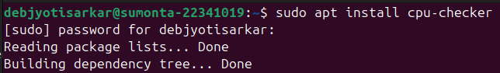

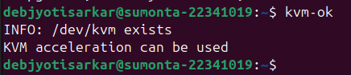

As KVM is supported, we need to install these packages for KVM and other things needed to run virtual machines

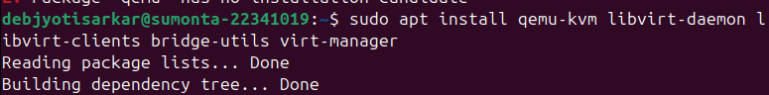

**Task 2**

To create a new virtual machine using GUI, we need to open Virtual Machine Manager and add a new virtual machine and enter the name and the iso file. Following that, we just need to go through the steps to have a running VM. Here, we can assign however much CPU cores, RAM, storage to the VM as we wish.

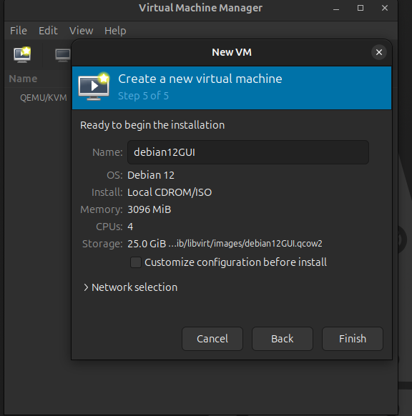

**Task 3**

To set up a VM using CLI, we need to do it using virt-install. The component of this command do the following: name - sets the name for the VM, memory - allocates the defined number of RAM in MB, vcpu - defines the CPU cores, disk-size - allocates the storage of the VM in GBs, cdrom - points to the directory where the iso file for the installation is stored, os-variant - defines the OS that is being used in the VM. Similar to the GUI method, after running this command we just need to go through the steps to install the VM.

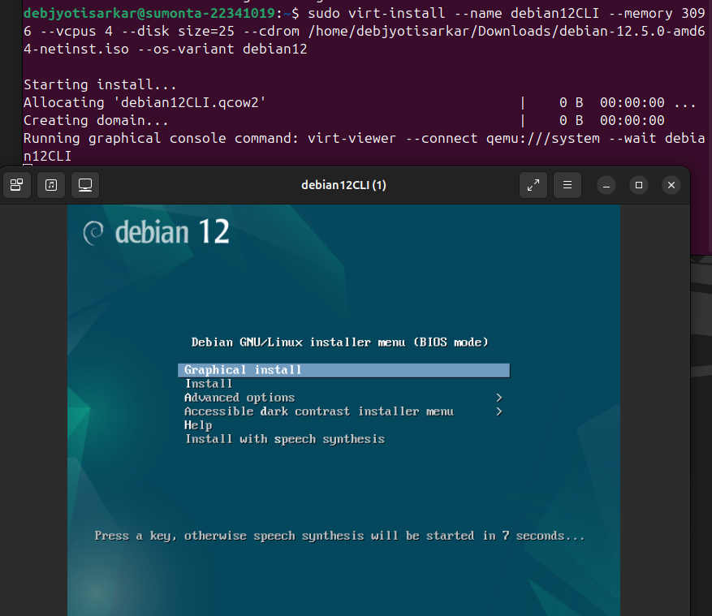

**Task 5**

To share a folder between guest and host, firstly I needed to install virtiofsd then edit the XML file of the VM

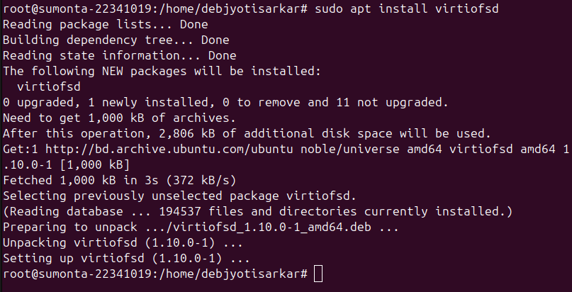



In the XML file added this part of code for allowing access to the shared folder.

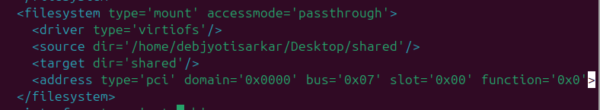

I created a new directory in the host machine and enabled read-write permission to that directory.

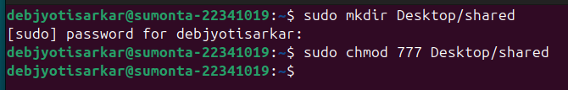

I started a virtisof Daemon with the correct oath to the shared folder, it will act as a socket for communication.

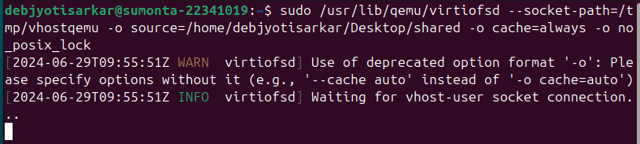

In the details -> add hardware -> select file system of the VM, I added both the source files and the target path.

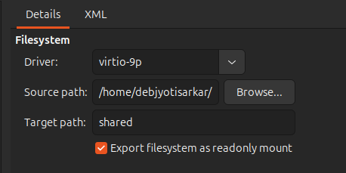

Now, in the VM, I got root access using sudo -s and made a directory in the VM and mounted it and the shared folder is ready and working.

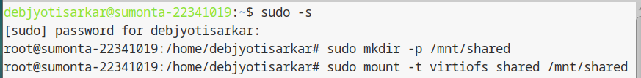

To check if the folder is actually working, I opened a text file in the VM and it appeared the same in the host machine as well.

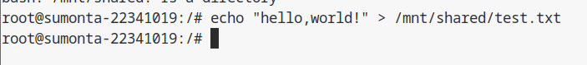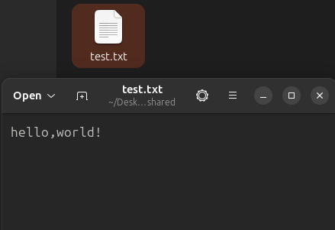

**Task 6**

To access the phone’s files in the guest OS, I used KDE connect. As we know, whenever we create a VM the host OS allocates a virtual IP using NAT for the guest OS and in order for the guest OS to access the files of the phone using the local network the network type had to be changed from NAT to bridge. In order to operate a bridge, we need to open nmtui first.



In nmtui, we need to create a bridge and add the current ethernet connection to the bridge. Following that, we also need to delete/deactivate the ethernet connection from the server in order to activate the bridge.

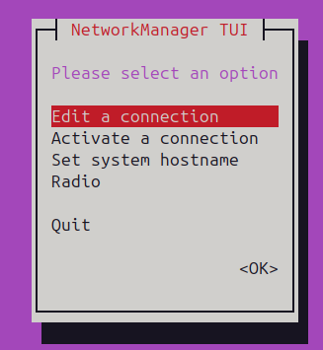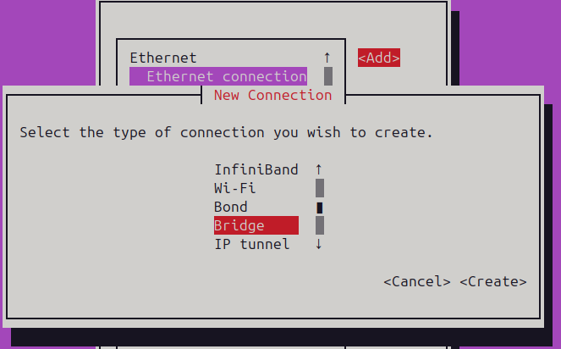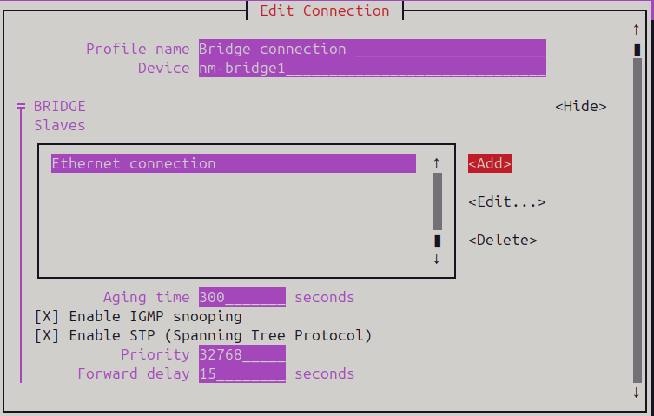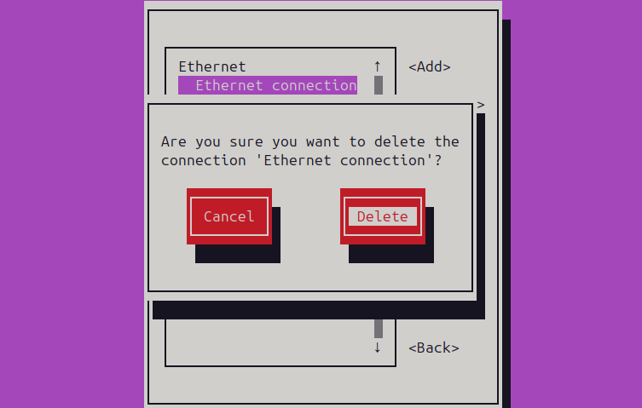

In the details of the VM, we need to change the network source to the bridge device.

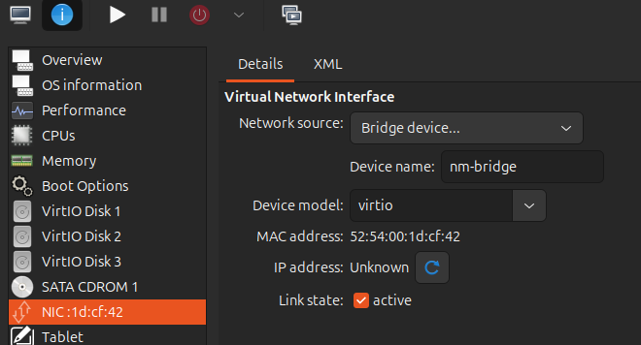

In the guest OS, we need to install KDE connect, it also needs to be installed on the phone from the app store.

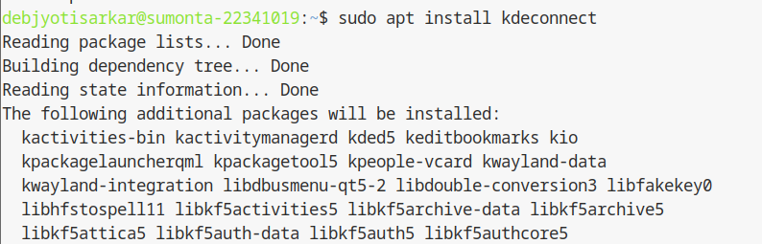

Inside the KDE connect app, it will show all the available devices the current network. In my case, my host machine and my phone were the two devices available.

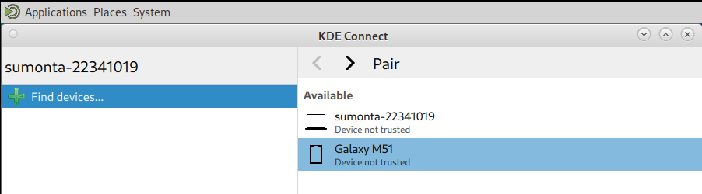

In the app, through the share file option, I can share any file from the phone to the VM or vice versa.

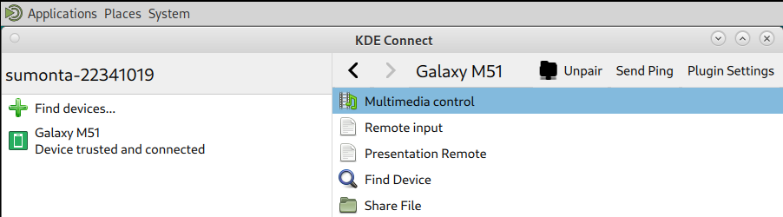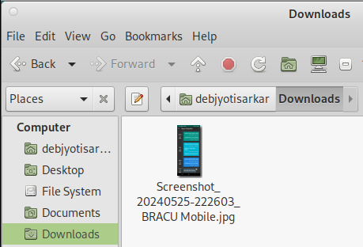

**Task 7**

To clone the VM using GUI, it’s just as simple as right clicking the VM and clicking clone and naming the new VM.

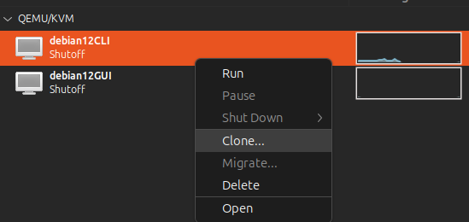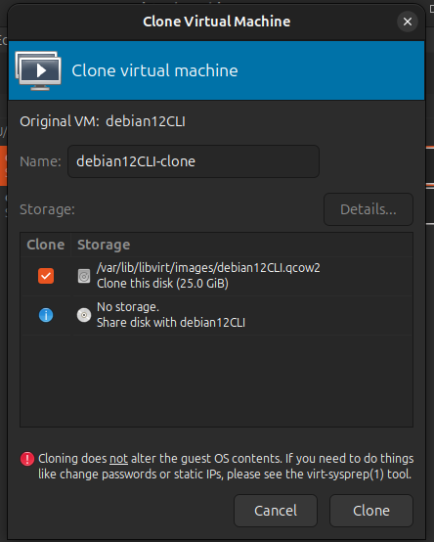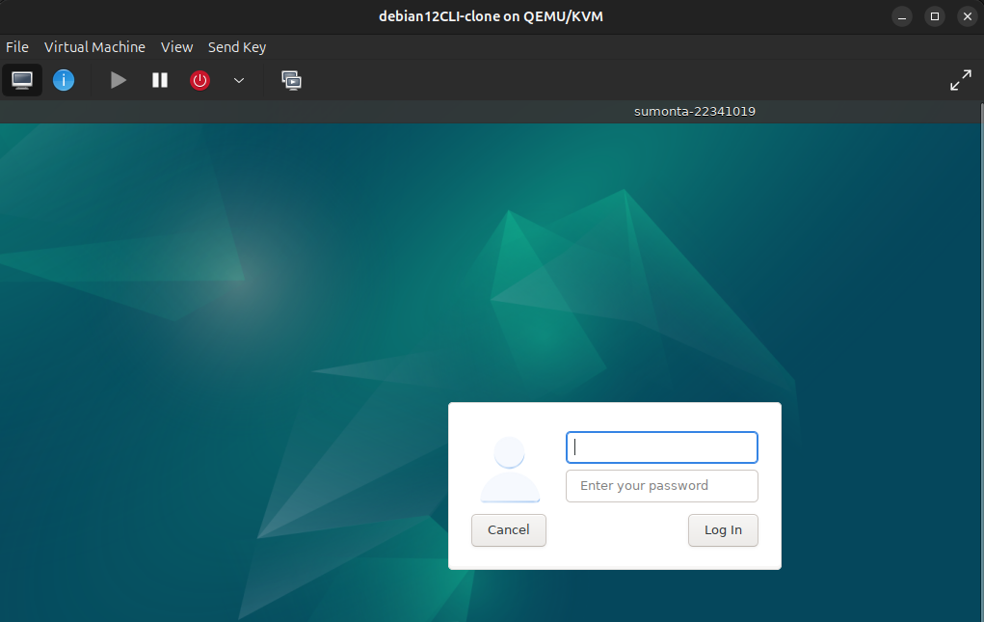

To clone the VM using CLI, we first need to install virtinst

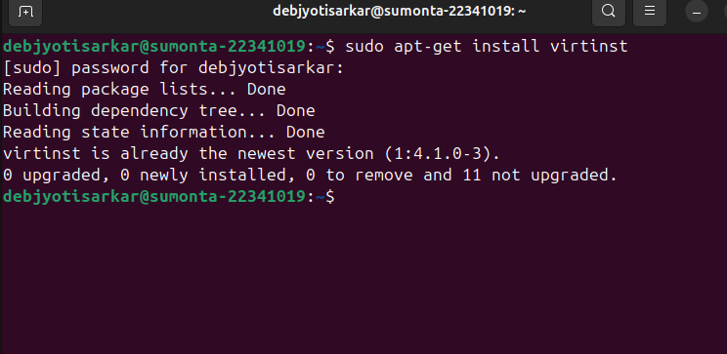

We can clone the system using virt-clone, the component of this command do the following:

Original: name of the original VM, name - name of the new VM, file - the directory of the original VM is stored.

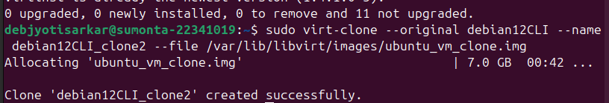

**Task 8**

To create new disks using GUI, we need to go to the details sections of the VM and go to the add hardware option. From there, in the storage option we can create new disks and allocate the designated storage capacity that we want.

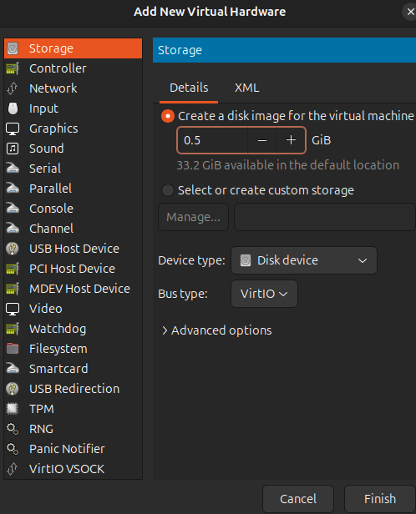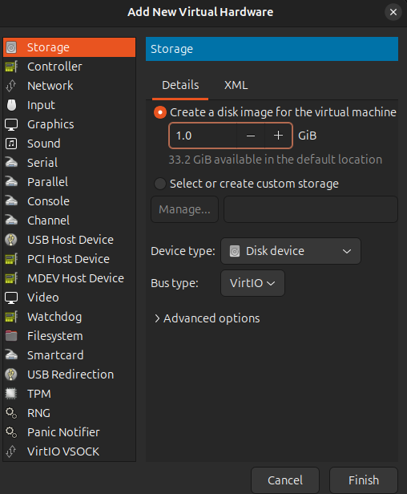

It shows all the disk options.

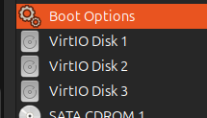

**Task 9**

In order to add two hard disks using CLI, we first need to create two disks using qemu-img create a disk and following that, the directory of the new file, mentioning the size of the new disk, 1G in my case.

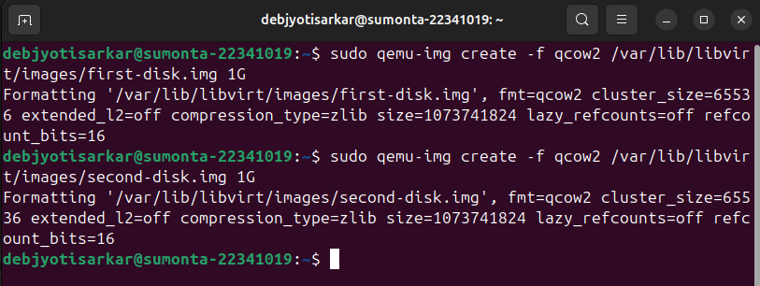

Using virsh attach-disk we can attach the newly created disks to the VM.

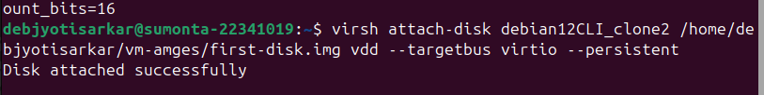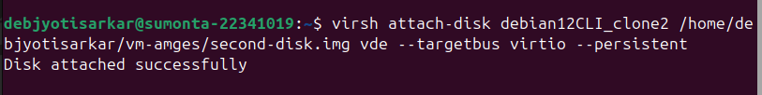

**Task 10**

To migrate a VM to another host, we first need a way to transfer the file. I am using a USB flash drive, I formatted it to Ext4 type to get it ready.

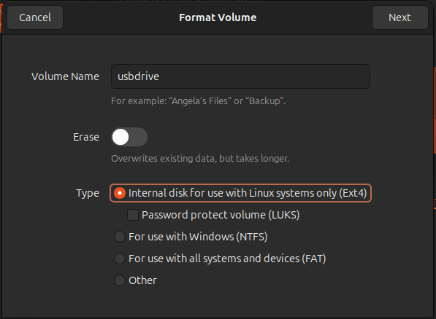

From the details section of the VM I want to migrate, I copied its original directory.

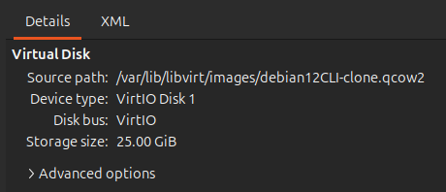

Firstly, I gave read-write permission using sudo chmod 777. Following that, I copied the file to the flash drive.

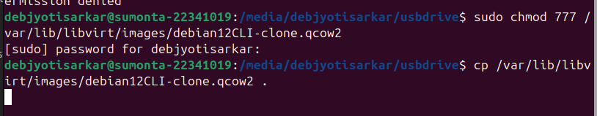

Now, in the new PC we need to copy the file from the flash drive to the local storage and click on the add a new VM option. From here, we need to choose the import existing disk image.

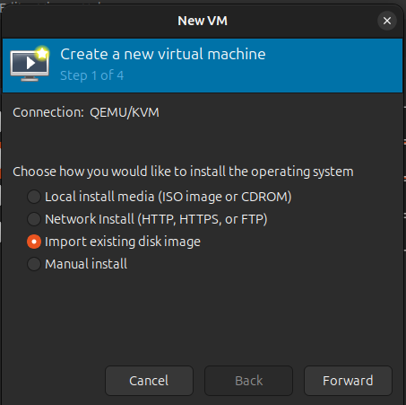

From there, I need to put the directory of where I stored the file in the local system and select the OS.

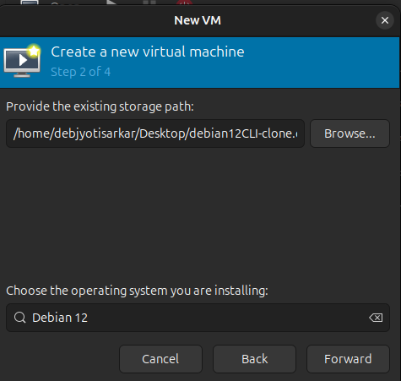

After allocating proper RAM, CPU and storage and naming my VM, the migration is complete and the VM is ready to be used.

